Aim: To obtain the classification of various classes using k-Nearest Neighbor approach
IDE: Google Colab

Theory:
This algorithm is used to solve the classification model problems. K-nearest neighbor or K-NN algorithm basically creates an imaginary boundary to classify the data. When new data points come in, the algorithm will try to predict that to the nearest of the boundary line. Therefore, larger k value means smother curves of separation resulting in less complex models. Whereas, smaller k value tends to over fit the data and resulting in complex models. It’s very important to have the right k-value when analyzing the dataset to avoid over fitting and under fitting of the dataset.

The model representation for KNN is the entire training dataset. It is as simple as that. KNN has no model other than storing the entire dataset, so there is no learning required. Efficient implementations can store the data using complex data structures like k-d trees to make look-up and matching of new patterns during prediction efficient. Because the entire training dataset is stored, you may want to think carefully about the consistency of your training data. It might be a good idea to curate it, update it often as new data becomes available and remove erroneous and outlier data.

K-NN algorithm assumes the similarity between the new case/data and available cases and put the new case into the category that is most similar to the available categories. K-NN algorithm stores all the available data and classifies a new data point based on the similarity. This means when new data appears then it can be easily classified into a well suite category by using K- NN algorithm. K-NN algorithm can be used for Regression as well as for Classification but mostly it is used for the Classification problems.

K-NN is a non-parametric algorithm, which means it does not make any assumption on underlying data. It is also called a lazy learner algorithm because it does not learn from the training set immediately instead it stores the dataset and at the time of classification, it performs an action on the dataset. KNN algorithm at the training phase just stores the dataset and when it gets new data, then it classifies that data into a category that is much similar to the new data.

Example: Suppose, we have an image of a creature that looks similar to cat and dog, but we want to know either it is a cat or dog. So for this identification, we can use the KNN algorithm, as it works on a similarity measure. Our KNN model will find the similar features of the new data set to the cats and dogs images and based on the most similar features it will put it in either cat or dog category.

Methodology:
- Load the basic libraries and packages
- Load the dataset
- Analyse the dataset
- Pre-process the data

- Visualize the Data
- Separate the feature and prediction value columns
- Select the number K of the neighbors
- Calculate the Euclidean distance of K number of neighbors
- Take the K nearest neighbors as per the calculated Euclidean distance.
- Among these k neighbors, count the number of the data points in each category.
- Assign the new data points to that category for which the number of the neighbor is maximum.
- Our model is ready.

Pre Lab Exercise:

- What is K in KNN-approach?
K represents the number of nearest neighbors used for classification.It decides how many nearby data points are considered.Choosing the right value of K is important for accuracy.

- Which are the types of distance metrices?
- Euclidean Distance
- Manhattan Distance
- Minkowski Distance
- Hamming Distance

- What can be the criteria of selection of the value of K?
K should not be too small or too large. Small K leads to overfitting. Large K leads to underfitting. Usually, odd values of K are preferred.

- What are the advantages of KNN algorithm?
- Simple and easy to understand
- No training phase required
- Works well with small datasets

Program (Code):
import time
import numpy as np
import pandas as pd
import matplotlib.pyplot as plt
import seaborn as sns
from sklearn.datasets import load_digits
from sklearn.model_selection import train_test_split, GridSearchCV
from sklearn.preprocessing import StandardScaler
from sklearn.pipeline import Pipeline
from sklearn.neighbors import KNeighborsClassifier
from sklearn.ensemble import RandomForestClassifier
from sklearn.neural_network import MLPClassifier
from sklearn.metrics import (
accuracy_score,
precision_score,
recall_score,
f1_score,
confusion_matrix
)

digits = load_digits()
X = digits.data
y = digits.target
images = digits.images

plt.figure(figsize=(8, 4))
for i in range(10):
plt.subplot(2, 5, i + 1)
plt.imshow(images[i], cmap="gray")
plt.title(f"{y[i]}")
plt.axis("off")
plt.suptitle("Sample Digits")
plt.tight_layout()
plt.show()
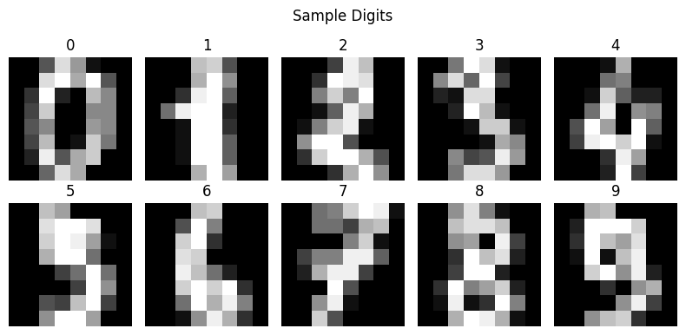
X_train, X_test, y_train, y_test = train_test_split(
X, y, test_size=0.2, random_state=42)

knn_pipeline = Pipeline([
("scaler", StandardScaler()),
("knn", KNeighborsClassifier())
])

knn_param_grid = {
"knn__n_neighbors": [3, 5, 7, 9, 13, 15, 20]}

rf_pipeline = Pipeline([
("rf", RandomForestClassifier(random_state=42))
])

rf_param_grid = {
"rf__n_estimators": [25, 50, 100, 200, 500],
"rf__max_depth": [None, 10, 20]}

mlp_pipeline = Pipeline([
("scaler", StandardScaler()),
("mlp", MLPClassifier(
max_iter=1000,
random_state=42,
early_stopping=True
))
])

mlp_param_grid = {
"mlp__hidden_layer_sizes": [(64,), (128,), (64, 64)],
"mlp__activation": ["relu", "tanh"],
# "mlp__alpha": [0.0001, 0.001],
"mlp__learning_rate_init": [0.001, 0.01, 1.0, 5.0, 10.0]
}

#Training the model
def train_with_timing(pipeline, param_grid):
start = time.time()
grid = GridSearchCV(
pipeline,
param_grid,
cv=5,
scoring="f1_weighted",
n_jobs=-1
)
grid.fit(X_train, y_train)
train_time = time.time() - start
return grid, train_time

knn_grid, knn_train_time = train_with_timing(knn_pipeline, knn_param_grid)
rf_grid, rf_train_time = train_with_timing(rf_pipeline, rf_param_grid)
mlp_grid, mlp_train_time = train_with_timing(mlp_pipeline, mlp_param_grid)

#Inferencing the model
def inference_time(model):
start = time.time()
model.predict(X_test)
return time.time() - start

knn_test_time = inference_time(knn_grid.best_estimator_)
rf_test_time = inference_time(rf_grid.best_estimator_)
mlp_test_time = inference_time(mlp_grid.best_estimator_)

#Evaluation
def evaluate_model(model):
y_pred = model.predict(X_test)
return {
"Accuracy": accuracy_score(y_test, y_pred),
"Precision": precision_score(y_test, y_pred, average="weighted"),
"Recall": recall_score(y_test, y_pred, average="weighted"),
"F1-score": f1_score(y_test, y_pred, average="weighted")
}

knn_metrics = evaluate_model(knn_grid.best_estimator_)
rf_metrics = evaluate_model(rf_grid.best_estimator_)
mlp_metrics = evaluate_model(mlp_grid.best_estimator_)

#Result with comparison
results_df = pd.DataFrame(
[knn_metrics, rf_metrics, mlp_metrics],
index=["KNN", "Random Forest", "MLP"]
)

results_df["Training Time (s)"] = [
knn_train_time, rf_train_time, mlp_train_time
]

results_df["Inference Time (s)"] = [
knn_test_time, rf_test_time, mlp_test_time
]

print(results_df)
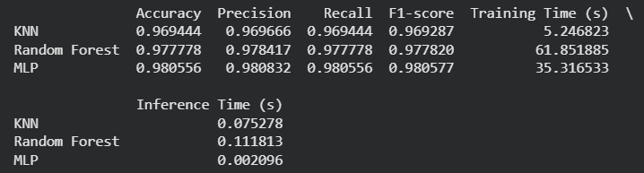

results_df.iloc[:, :4].plot(kind="bar", figsize=(10, 6))
plt.title("Model Performance Comparison (Digits)")
plt.ylabel("Score")
plt.ylim(0, 1)
plt.xticks(rotation=0)
plt.grid(axis="y")
plt.show()
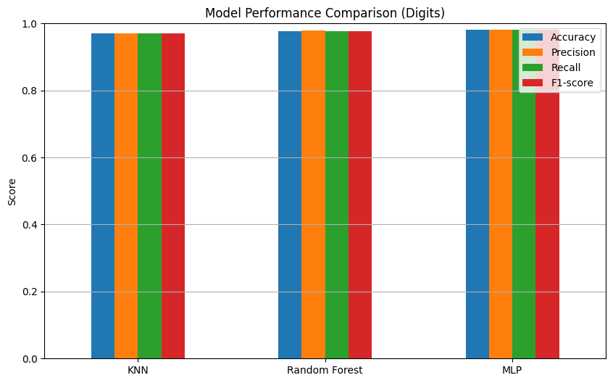
models = {
"KNN": knn_grid.best_estimator_,
"Random Forest": rf_grid.best_estimator_,
"MLP": mlp_grid.best_estimator_
}

fig, axes = plt.subplots(1, 3, figsize=(18, 5))

for ax, (name, model) in zip(axes, models.items()):
cm = confusion_matrix(y_test, model.predict(X_test))
sns.heatmap(cm, annot=True, fmt="d", cmap="Blues", ax=ax)
ax.set_title(name)
ax.set_xlabel("Predicted")
ax.set_ylabel("Actual")

plt.tight_layout()
plt.show()

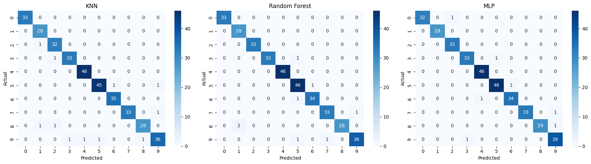

Observation and Result Analysis:
- Nature of the dataset
The dataset contains numerical features and class labels. It is used for classification problem. Data is properly structured and labeled.

- During Training Process
KNN does not perform actual training. It stores the dataset for future use. No model is built during training.

- After the training Process
The model predicts new data based on nearest neighbors. Classification is done using majority voting.
Accuracy depends on value of K.

- Observation over the Learning Curve
The model performance depends on K value. Proper K gives better accuracy. Too small or large K reduces performance.

Post Lab Exercise:
- Is KNN useful in regression-based problems?
Yes, KNN can be used for regression. It predicts values by averaging nearest neighbors. But it is mostly used for classification.

- Why KNN is a non-parametric algorithm?

KNN does not assume any data distribution. It uses actual data for prediction. Hence, it is called non-parametric.

- What are the assumptions of KNN approach?
Data points that are close are similar. Distance metric correctly measures similarity. All features contribute equally.

- How can the KNN approach make the prediction of the unseen dataset?
It finds K nearest neighbors of new data. Then it checks their classes. The majority class is assigned to new data.

- Why is KNN called a Lazy Learner?
KNN does not learn during training phase. It stores the dataset and works during prediction. Hence, it is called lazy learner.

- Why should we not use KNN for large dataset?
KNN requires storing entire dataset. Prediction is slow for large data. It takes more time and memory.

